* Go to AWS console and create EC2 instances

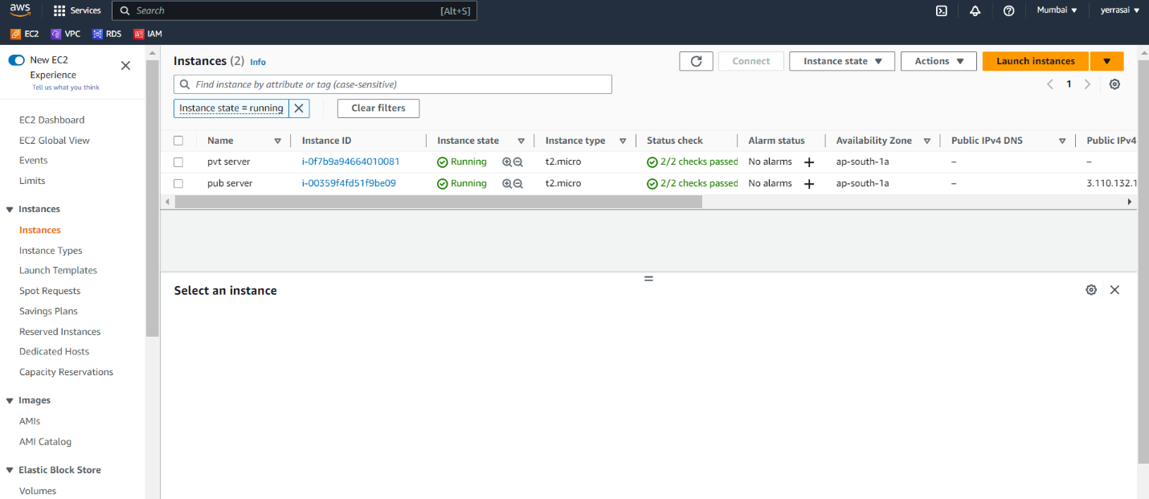

* Connect to that instance by using ssh key.

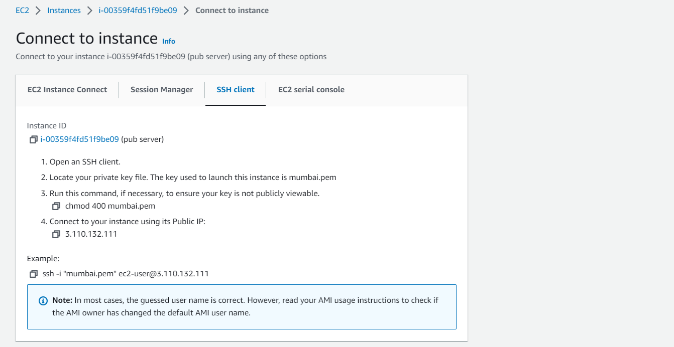

* Copy and paste the ssh.key in terminal.
* After connecting to public instance, in that connect to private instance.

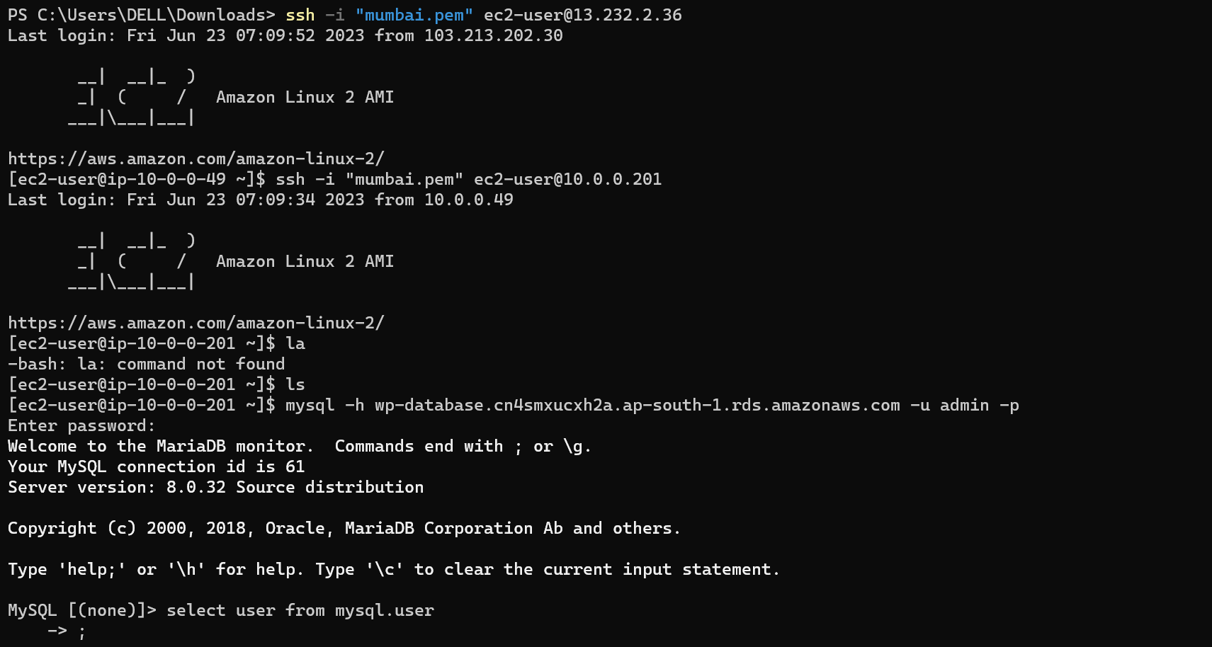

* In private instance install mysql by using command “sudo yum install -y mysql”
* Connect to mysql with endpoint of the database.

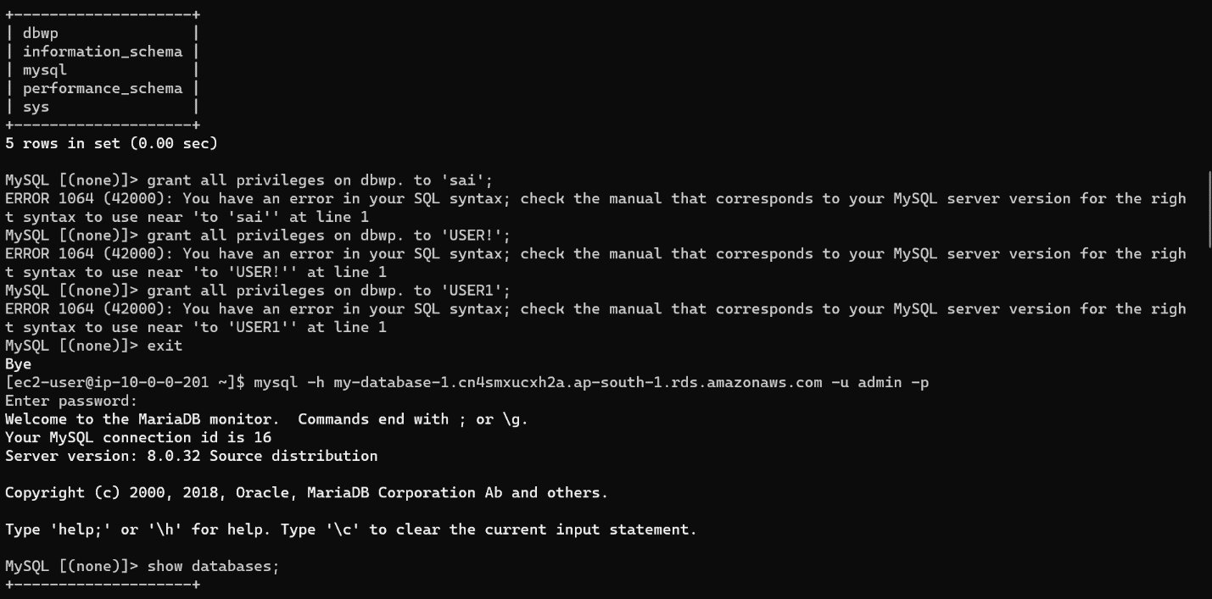

* Create user with password for database.

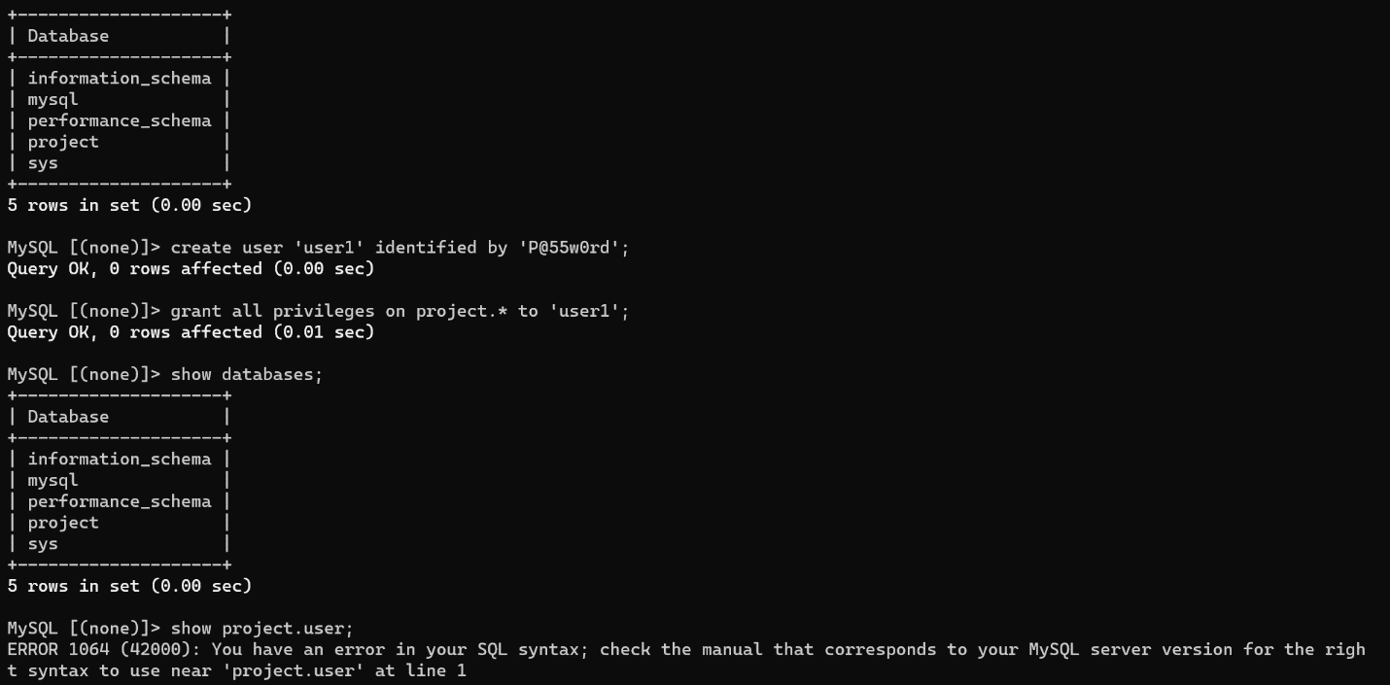

* Now, exit from the private instance.
* In public instance install WordPress, httpd, mysql.
* After installing WordPress there will be one file that is WordPress.
* Change directory to that WordPress file, in that WordPress directory there are some files.
* Here we have to edit wp-config.php file

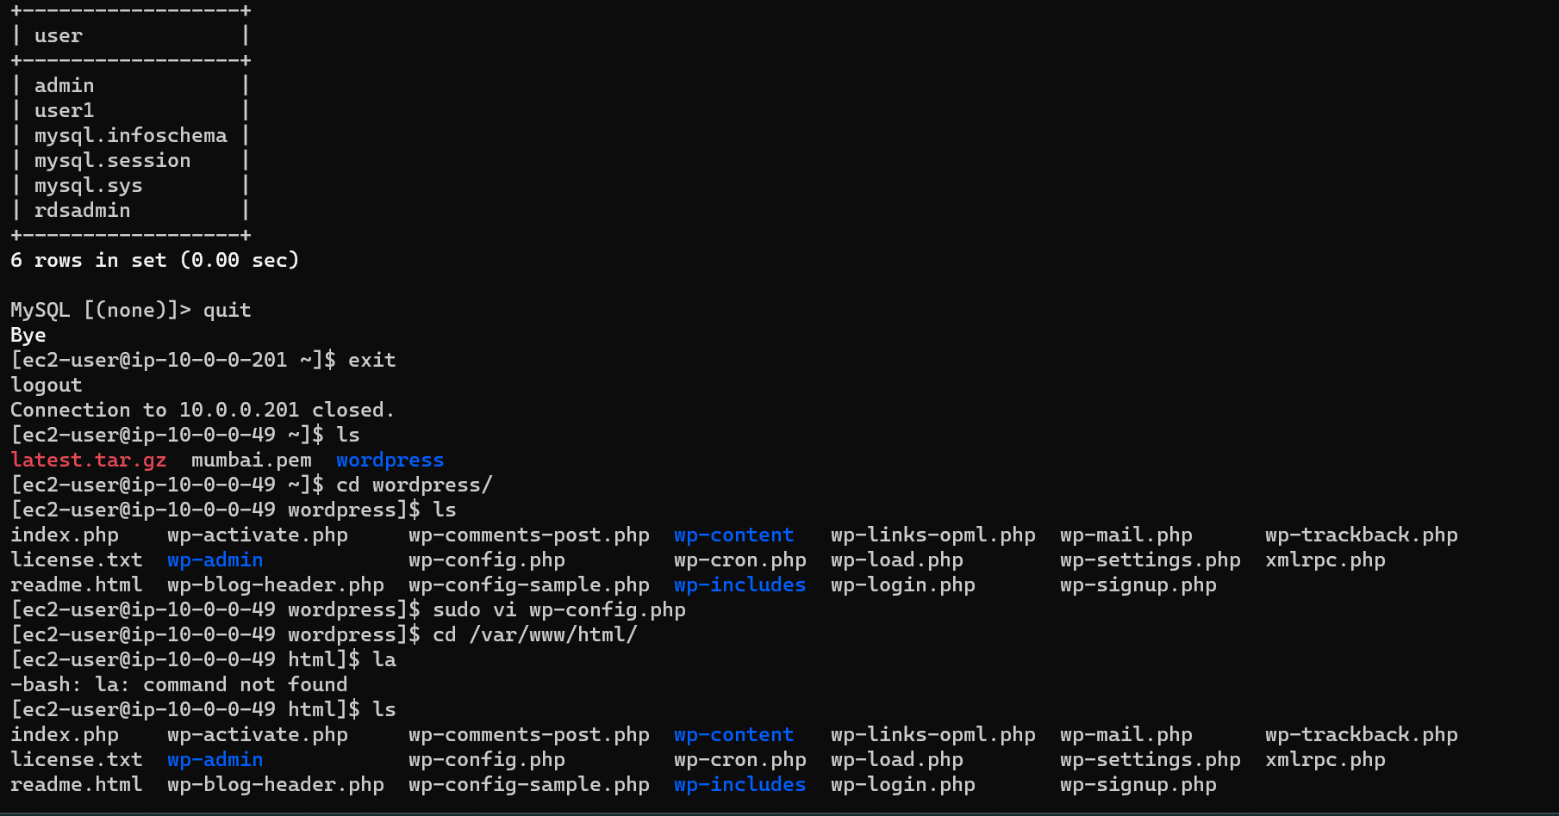

* Here add secret key and credentials.
* Copy files to /var/www/html path.
* Then do restart httpd. service.
* Do sudo systemctl restart httpds.
* And see the status of httpd, it will be shown as active.

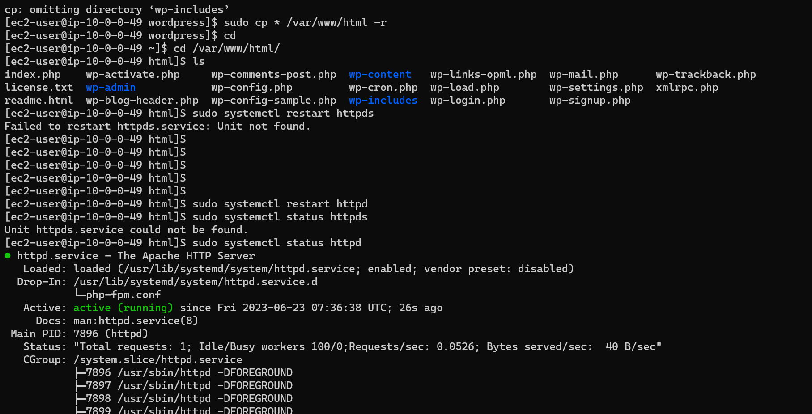

* By copy public ip address in website to see the output.

